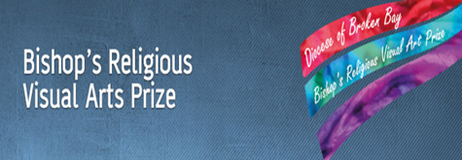
Entry Form
(To be pasted on the back of your artwork)

Student
First name |  | Surname
School |  |  | School suburb
Year group
Artist’s description of their artwork
(Include the Biblical reference e.g. Mark 1:1, a brief explanation of the meaning of the Biblical verse and an explanation of why you decorated and illustrated the verse in the way you did. See over for example)
Parent / Guardian Information (Diocesan judging only)
First name |  | Surname
Email |  |  |  | Mobile Phone
- I acknowledge that the rights of others have not been infringed in the creation of the artwork
- I give my permission for photographs of the artwork to be used in school and Diocesan publications, promotions and websites etc without compensation.
- I acknowledge that if an artwork contains an image of a child under 18 years of age, that I have the express permission of the child's parent / guardian.
- I indemnify the Catholic Diocese of Broken Bay against any losses that result from any false information provided.
- I understand that all the conditions of entry must be met otherwise artworks will not be accepted.
I agree to the above Terms and Conditions
Parent’s/ Guardian’s Signature: _______________________________

Artworks 2018
Artworks may only be in one of the Visual Arts media including painting, drawing, print, photography etc. No sculptures, animation or video entries will be accepted.
Students are invited to prayerfully select a favourite verse of Scripture from the Old or New Testament and to decorate and/or illustrate it using a traditional or contemporary form of illumination. Students in ES1 and S1 (Years K-2) may simply submit an illustration of a Biblical story or verse. Students are asked to share a reflection on the meaning and significance of the verse and to include it with their submission.
Artworks are limited to individual entries on a single A4 or A3 page of art paper (or paper of similar heavier weight and special texture). This Entry Form should be lightly glued to the back of the artwork. Students are encouraged to laminate their entry to prevent any damage occurring to their artwork.
The artwork should of course be the student’s own work. The artwork should not be a student’s copy of the art of a professional artist. If the artwork contains an image of another person/s (e.g. their face) their permission should be sought and gained preferably in writing, explaining that the artwork will be included in an exhibition that will be viewed by other people.
For further explanation and many examples of illuminated Biblical texts go to http://bishopsartprize.weebly.com/

This is the illuminated text the student is talking about.  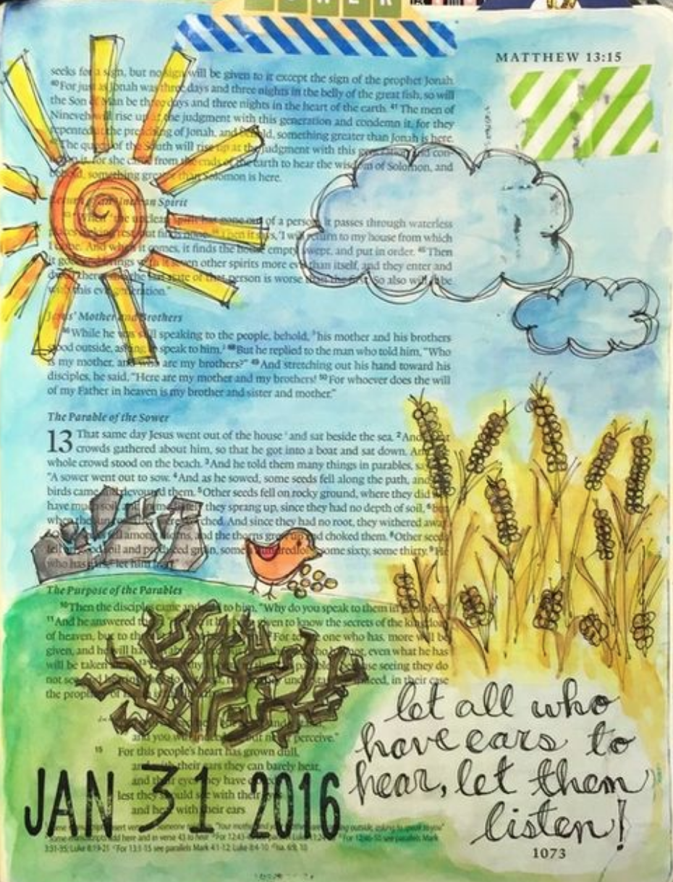 | Sample Artist’s description of their artwork  (Include the Biblical reference e.g. Mark 1:1, a brief explanation of the meaning of the Biblical verse and an explanation of why you decorated and illustrated the verse in the way you did)
Biblical reference e.g. Mark 4.23

I have always enjoyed hearing the Parable of the Sower. I chose this verse because in telling the parable I think Jesus is being funny. I found out that in the ‘ears’ of wheat or barley are contained the seeds which fall from the sower’s hand onto different kinds of soil. Having just told a parable about a sower who went out to sow wheat or barley seeds, he finishes by saying to those listening, ‘Let all with ears to hear, listen’.

I hope in my life that I am like the good soil and that listening to God’s Word will help me live a good life in helping of others. Listening to God’s Word means reading the Bible often, thinking about what it means and putting it into practice.

I have illustrated the different types of places the seed fell upon. I drew the sun and clouds because seeds also need light and water, which are like going to a Catholic school.

