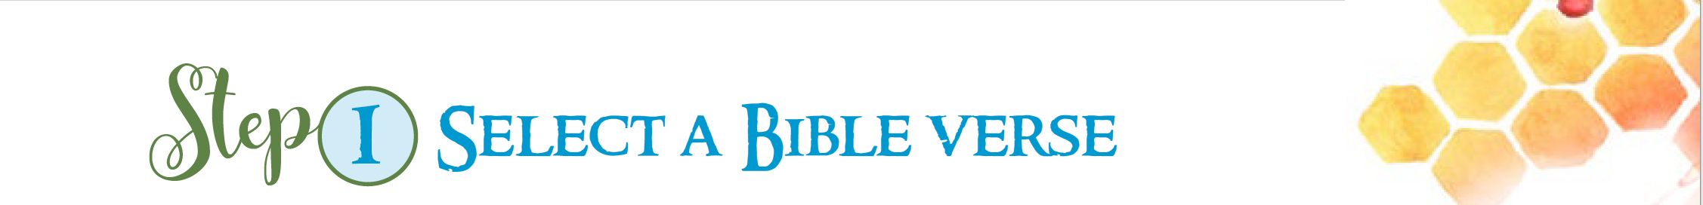
Do you have a favourite passage, verse or saying from the Bible? It might be something you’ve learnt about in class or heard read in Mass. You could ask family members about their favourite Bible passage. It might be a story about the creation of the world or Moses or a story about Jesus or a story told by Jesus. Click here for some popular Bible verses or here for favourite Bible verses or look up what the Bible has to say on something you have been thinking about.
After you have chosen a Bible verse, think about what those words from the Bible mean to you. What do they tell us about God and the world, about God and us, about other people and how we should treat them?
- Do you like writing? What’s your handwriting like?
- There are many different styles of handwriting. There are many different kinds of fonts which all have their own names. Click here to view many different kinds of fonts.
- What style of letters do you like best?
- Select a font and practise writing your selected Bible verse.
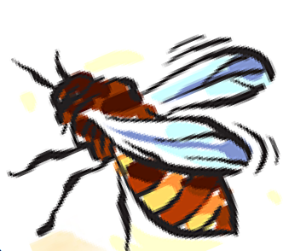
Think about how you might decorate that Bible verse
As you begin to decorate and maybe even illustrate your favourite Bible verse, you begin to think like an artist. Your writing becomes a work of art. Click here to view some of the many different ways of decorating a Bible verse.
Experiment with different types of writing, decoration and illustration before attempting your final work for entry into the Prize. Ask your teachers and family for suggestions.
